Project Title: **Sneaky Shoes E-Commerce**

Group Name: **UNT-DEV**

Team Members List:

* RAHEEM ALI
* GIRISH VARDHAN GAVIREDDY
* SAI KIRAN REDDY SOMA
* LETHASWI THOKALA
* PRATHYUSHA REDDY PIPPIRADA
* LIKHITHA REDDY SAMA
* SAI VENKATARAMA INNAMURI

**Phase 2:** (Deadline: 10-04-2023)

In this phase Our team plan to do majority of the Back-end Development.

This includes the prioritize functionalities as follows:

|  |  |  |
| --- | --- | --- |
| S.no | Features | Priority |
| 1. | Buy option and product Design (back-end) | P1 |
| 2. | Add to cart | P2 |
| 3. | Payment Option | P3 |
| 4. | Filter Option | P4 |

# Buy option and product Design (back-end):

A user-friendly product design can help improve the overall user experience of an e-commerce website. This can lead to increased customer satisfaction and loyalty. Our website is well-designed product page with high-quality images, clear product descriptions, and user-friendly interface can attract and engage customers, which can lead to increased sales.

* Designed a schema for the product at the back end using node.js and JavaScript.
* With the help of this schema, we can identify the product easily and this helps the user search and purchase easily.

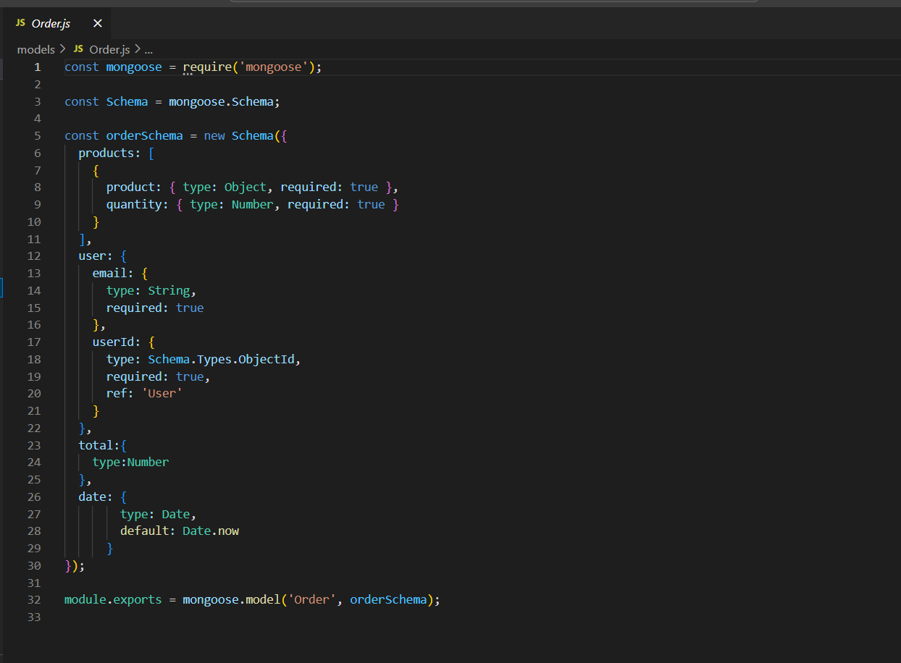

**Use Case Diagram:-**

# Add to cart

The "Add to Cart" feature in Sneaky shoes e-commerce refers to the functionality that allows customers to add items they wish to purchase to a virtual shopping cart on the website. This feature is an essential part of the e-commerce experience, as it provides customers with the ability to collect and manage the products they intend to buy before completing the checkout process.

* Add to card is important feature in our website. This help user to browse all the items on the website and buy all the item in a single time in a single click.
* This feature enables user to purchase more with fewer clicks and easy to buy.
* It helps to save a time if any user wants to buy 2 or more item.

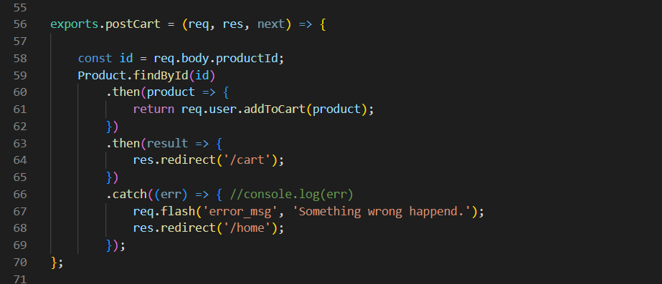

**Use Case Diagram:-**

# Payment Option

Our Payment System is virtualized currency or tokens which will be used for the payment option. With this our users of sneak shoes will be easily able to buy the shoes from our website.

This payment option that allows users to test the checkout process on an e-commerce website without actually processing a real payment. It is a useful feature for testing the functionality of the checkout process and for allowing users to practice placing order without incurring any actual charges.

Here are some benefits of using our virtualized dummy payment method in a sneak shoe’s website.

* Testing
* Training
* User Experience
* Confidence
* Cost Saving

Overall, this payment method is a valuable feature that can improve the UI/UX, increase customer confidence, and reduce costs for business. It is especially useful during testing and training phases, as well as for helping customers feel more comfortable with the checkout process.

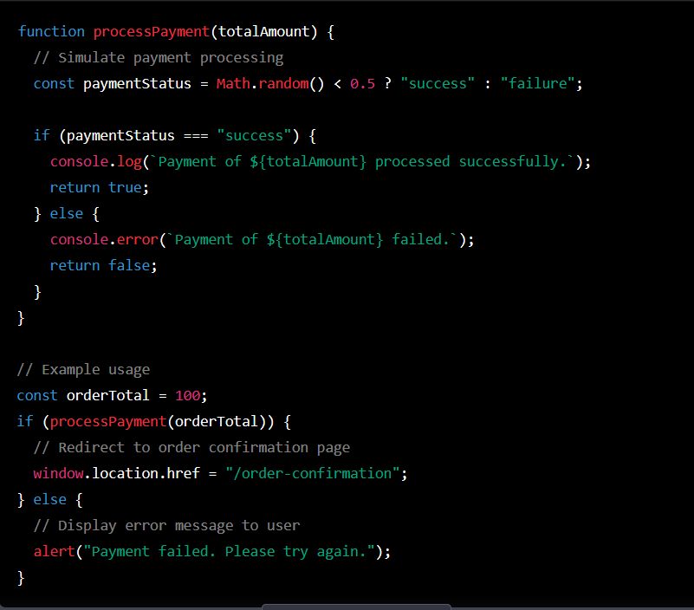

**Use Case Diagram:-**

# Filter Option

The filter option in our website allows customers to narrow down their product search based on specific criteria, such as price range, and other product attributes. This feature is an essential part of the e-commerce experience, as it provides customers with a quick and easy way to find the products they are looking for and make informed purchasing decisions.

* This feature helps the user to get out the specific product.
* We attach a unique id to every product item. In this we can easily find the product and perform actions on it.
* There are multiple products displayed on the website it is easy for user to find specific product that they are looking for.

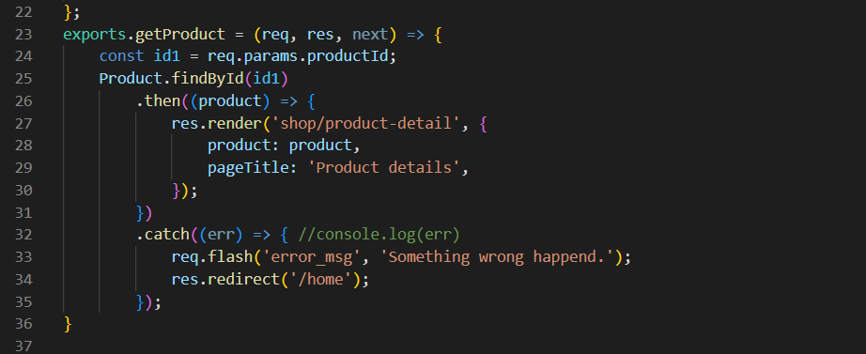

**Use Case Diagram:-**

**Test Cases**

1. If the user has already created an account, then it shows a message that “this email is already registered”. And this redirected to login page. 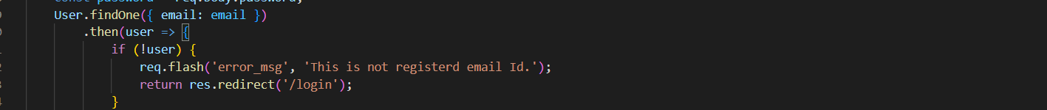
2. If the user enters wrong password, then it shows an error message of wrong password. 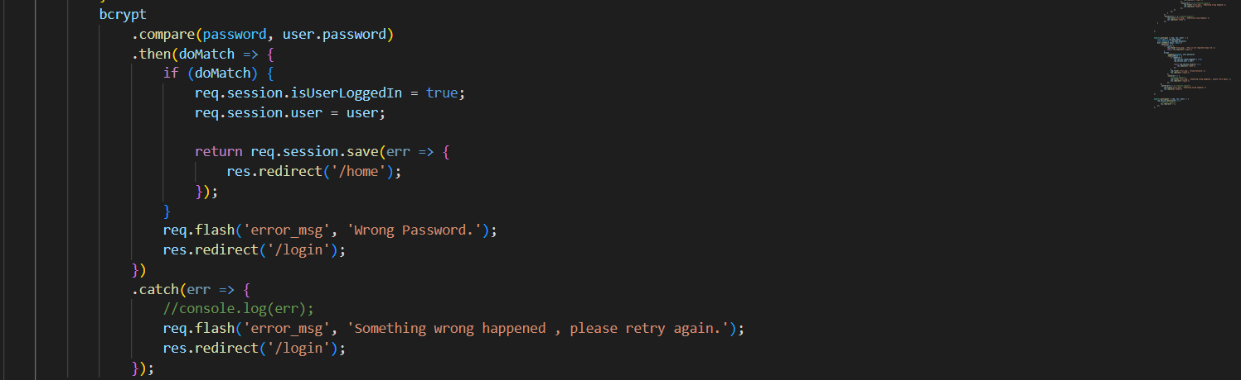
3. If any unexpected error happens then it shows an error message. 
4. If there is an error creating a new profile then it shows an error message. 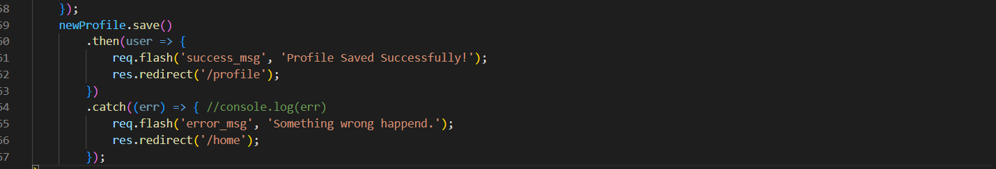
5. If something went wrong on add to cart feature the shows then display an error message. After this it will redirect it to the home page.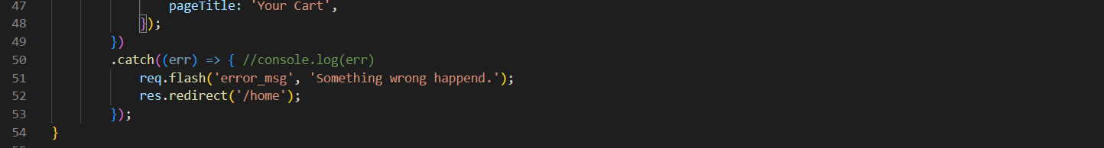
6. If the item doesn’t get deleted from the cart the it displays an error message. A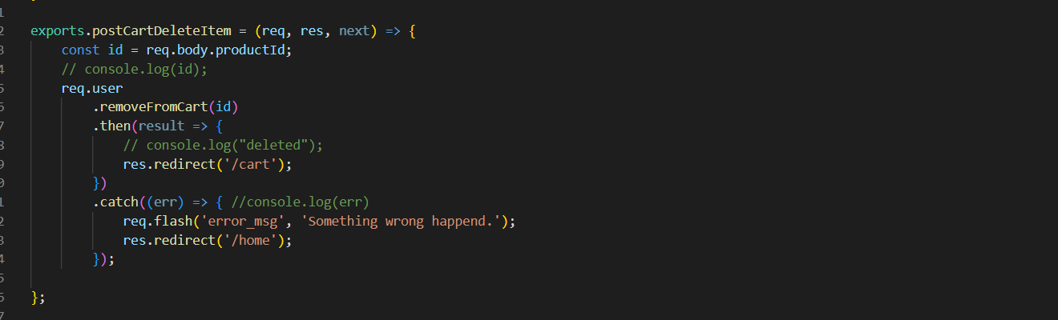

**Report Code Inspection**

During the code Inspection the other them suggest us to use a dummy payment system due to less duration of time. Other then that we are on the track for the development of the website.

**Report Reflection**

After the code inspection, we had a team discussion and decided to implement the dummy payment system for two reasons.

1. Due to less duration of timeline, it is hard to get integration of API of PayPal or other services to our website.
2. With the help of this payment system testing our website effective.

**User Manual**

1. From GitHub Repository (https://github.com/ralei0/UNT-Dev), click on Clone
2. Copy the clone URL
3. In Terminal (Mac) or command line (Windows git bash), move to local directory
4. Use the **git clone** command **along with the copied URL.**
5. After cloning, in Terminal type: “**npm install**”.
6. The finally run script: “**node app.js”**.
7. Open the browser and in type: “localhost:3000”

**Report Member Contribution**

|  |  |
| --- | --- |
| Team Member’s Name | Contribution |
| RAHEEM ALI | Build Authentication for the user for login in to the website. While update app.js file and worked on the add to cart, filter and admin privileges. |
| GIRISH VARDHAN GAVIREDDY | Create a form for both admin and user |
| SAI KIRAN REDDY SOMA | Worked on new profile section and shopping feature of the website. |
| LETHASWI THOKALA | Working on the integration of the payment system |
| PRATHYUSHA REDDY PIPPIRADA | Worked on the filter option of the website. |
| LIKHITHA REDDY SAMA | Worked on error handling of the website. |
| SAI VENKATARAMA INNAMURI | Checkout and cart feature of the website. |